**Rockbridge County Public Schools**

***Chromebook Policy and Use Handbook***

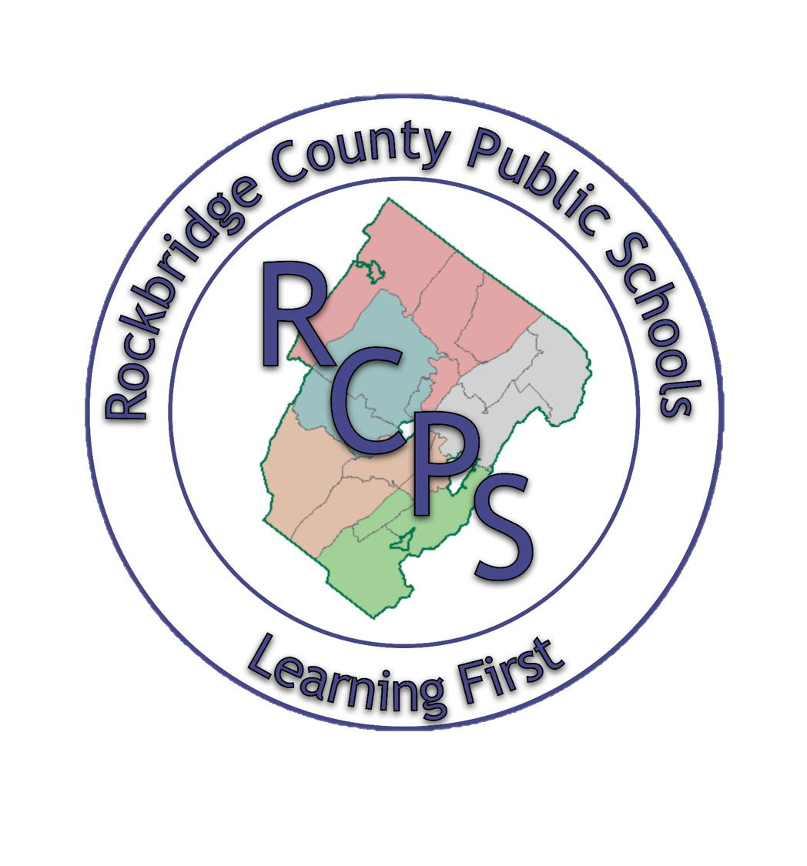

**Disclaimer:** The policies, procedures, and information within this document apply to all Chromebooks used at Rockbridge County Public Schools by students, staff, or guests including any other device considered by the Administration to fall under this policy.

**Teachers may set additional requirements for Chromebook use in their classroom.**

**\*Note:**​ ALL Students will be required to use District owned devices due to software requirements and management services.

Students attending Rockbridge County Schools can be issued Chromebooks for use in school and at home. This document provides students and their parents/guardians with information about taking care of the equipment, using it to complete assignments, and being a good digital citizen.

**Ownership of the Chromebook**

Rockbridge County Public Schools retain sole right of possession of the Chromebook. The Chromebooks are loaned to the students for educational purposes for the academic year. Moreover, RCPS administrative staff and faculty retain the right to collect and/or inspect Chromebooks at any time, including via electronic remote access and to alter, add, delete installed software or hardware.

**Student Responsibility**

Students are solely responsible for the Chromebooks issued to them and must adhere to the following:

Students

● must comply with the Chromebook Agreement, RCPS Acceptable Use Policy, and all policies of the school district when using their Chromebooks. Students are responsible for all activity within their G-Suite for Education account.

● must bring their Chromebooks to school every day and make sure it is fully charged. Note: A fully charged Chromebook should last 6.5 hours charged.

● must treat their device with care and never leave it in an unsecured location.

● must keep their device in the protective case provided by the school.

● must promptly report any problems with their Chromebook to tech support.

● may NOT remove or interfere with the serial number and other identification.

● may not attempt to remove or change the physical structure of the Chromebook, including the keys, screen cover or plastic casing.

● may not attempt to install, modify or run any operating system on the Chromebook other than the Chrome OS operating system supported by the school.

* May not attempt to bypass or attempt to bypass filtering or security measures included with the Chromebook.

**Taking Care of Your Chromebook:**

Students are responsible for the general care of the Chromebook which they have been issued by the school. Chromebooks that are broken or fail to work properly must be reported to the student helpdesk. If a loaner Chromebook is warranted, one will be issued to the student until their Chromebook can be repaired or replaced.

**General Precautions:**

● No food or drink is allowed next to your Chromebooks while it is in use.

● Cords, cables, and removable storage devices must be inserted carefully into the Chromebook.

● Students should never carry their Chromebook while the screen is open unless directed to do so by a teacher.

● Chromebooks should be shut down when not in use to conserve battery life.

● Chromebooks should never be shoved into a locker or wedged into a book bag as this may break the screen.

● Do not expose your Chromebook to extreme temperature or direct sunlight for extended periods of time. Extreme heat or cold may cause damage to the laptop.

● Always bring your Chromebook to room temperature prior to turning it on.

**Carrying the Chromebook:**

The protective shell of the Chromebook will only provide basic protection from everyday use. It is not designed to prevent damage from drops or abusive handling. Carrying the Chromebook in a padded backpack or padded bookbag is acceptable provided the backpack or bookbag is handled with care. For example, you shouldn’t toss the bag or drop the bag if your Chromebook is inside.

**Screen Care:**

The Chromebook screen can be damaged if subjected to rough treatment. The screens are particularly sensitive to damage from excessive pressure on the screen.

● Do not lean on top of the Chromebook.

● Do not place anything near the Chromebook that could put pressure on the screen.

● Do not place anything in a backpack that will press against the cover.

● Do not poke the screen.

● Do not place anything on the keyboard before closing the lid (e.g. pens, pencils, notebooks).

● Clean the screen with a soft, dry anti-static, or micro-fiber cloth. Do not use window cleaner or any type of liquid or water on the Chromebook. You can also purchase individually packaged pre-moistened eyeglass lens cleaning tissues to clean the screen. These are very convenient and relatively inexpensive.

● Do not spray directly on the Chromebook screen. Apply cleaner to cleaning cloth and proceed to clean Chromebook screen.

**Using Your Chromebook**

**At School:**

The Chromebook is intended for use at school each and every day. In addition to teacher expectations for Chromebook use, school messages, announcements, calendars, academic handbooks, student handbooks and schedules may be accessed using the Chromebook. Students must be responsible for bringing their Chromebook to all classes, unless specifically advised not to do so by their teacher.

**At Home:**

All students are required to take their Chromebook home each night throughout the school year for charging. Chromebooks must be brought to school each day in a fully charged condition. Students need to charge their Chromebooks each evening.

**Working offline**

Students without Internet access at home, or students in special situations (such as a long-distance bus ride for an activity) have several options for working “offline”, including:

* Google Drive (Docs and Sheets) allows students to switch to offline editing functionality, where preloaded documents can still be viewed and edited.
* Students may read and answer email offline, with changes being synchronized back to their online account when the Chromebook is re-connected to an Internet connection.

**Accessing the Internet at Home and Elsewhere**

Students are allowed to connect to wireless networks when their Chromebooks are at home, or in other venues where connectivity is offered (such as the Rockbridge Regional Public Library, other school districts on activity trips, etc). Please Note that Rockbridge County Schools cannot provide any assistance, troubleshooting, or advice on such off site connectivity.

When connecting from home, students and parents should be aware that a district account is still being used, so website monitoring is still being done. No matter the location, students are always using their account assigned by the school district.

**Sound:**

Sound must be muted at all times unless permission is obtained from the teacher for instructional purposes. It is recommended that student bring personal headset or ‘earbuds’ for any audio projects they work on.

**Printing:**

**At School:** Printing functionality will be available on a very limited basis at school and subject to classroom requirements. Teaching strategies will facilitate digital copies of homework.

**At Home:** The Chromebook will not support a physical printer connection. Instead, users may print to their home printers using the Google Cloud Print service. A wireless home network is required for this. <http://google.com/cloudprint>. Please note that Rockbridge County Schools cannot provide any assistance, troubleshooting, or advice on such off site printing.

**Managing Your Files and Saving Your Work:**

Students should save documents to their Google Drive, or they may in some cases save to an external memory device such as a USB flash drive. Saving to Google Drive will make the file accessible from any computer with internet access. Students using Google Drive to work on their documents will not need to save their work, as Drive will save each keystroke as the work is being completed. It will be the responsibility of the student to maintain the integrity of their files and keep proper backups. Students will be trained on proper file management procedures.

**Personalizing the Chromebook:**

The Chromebook must remain free of any decorative writing, drawing, stickers, paint, tape, or labels that are not the property of Rockbridge County Public Schools. Spot checks for compliance will be done by administration or RCPS Technicians at any time. Students will be allowed to personalize their case with school appropriate materials.

Students may add appropriate music, photos, and videos to their Chromebook. Personalized media are subject to inspection and must follow the Rockbridge County Public Schools District acceptable use policy.

**Software on Chromebooks:**

Originally Installed Software: Chromebook software is delivered via the Chrome Web Store. These are web-based applications that do not require installation space on a hard drive. Some applications, such as Google Drive, are available for offline use. The software originally installed on the Chromebook must remain on the Chromebook in usable condition and easily accessible at all times.

All Chromebooks are supplied with the latest build of Google Chrome Operating System (OS), and many other applications useful in an educational environment. The Chrome OS will automatically install updates when the computer is shutdown and restarted. From time to time the school may add software applications for use in a particular course. This process will be automatic with virtually no impact on students. Applications that are no longer needed will automatically be removed by the school as well.

**Additional Software:**

Students are unable to install additional software on their Chromebook other than what has been approved by Rockbridge County Schools.

**Inspection:**

Students may be selected to provide their Chromebook for inspection. The purpose for inspection will be to check for proper care and maintenance as well as inappropriate material being carried into the school.

**Procedure for Restoring the Chrome OS:** If technical difficulties occur, technical support staff will use the “5-minute” rule. If the problem cannot be fixed in 5 minutes, the Chromebook will be restored to factory defaults. In a One-to-One environment it is impossible for support staff to maintain a working environment for all if too much time is spent fixing every glitch that may arise. Restoring the Chrome OS will restore the device to the state in which the user originally received it. All student created files stored on an external miniSD card, USB flash drive, or Google Drive will be intact after the operating system is restored. All files saved on the chromebook that have been synced to Google Drive will be intact. However, all other data (music, photos, documents) stored on internal memory that has NOT been synced will not be restored.

**Protecting & Storing Your Chromebook:**

**Chromebook Identification:**

Chromebooks will be labeled in the manner specified by the school. Chromebooks can be identified in the following ways:

* Record of serial number and EPS asset tag
* Individual’s Google Account username *Under no circumstances are students to modify, remove, or destroy identification labels.*

**Storing Your Chromebook:**

When students are not monitoring their Chromebook, they should be stored in their lockers *with the lock securely fastened.* Nothing should be placed on top of the Chromebook, when stored in the locker. Students need to take their Chromebook home with them every night. The Chromebook is not to be stored in their lockers or anywhere else at school outside of school hours. The Chromebook should be charged fully each night at the student’s home. Chromebooks should never be stored in a vehicle.

**Storing Chromebooks at Extra-Curricular Events:**

Students are responsible for securely storing their Chromebook during extra-curricular events.

**Chromebooks Left in Unsupervised / Unsecured Areas:**

Under no circumstance should a Chromebook be stored in unsupervised areas. Unsupervised areas include the school grounds and campus, the cafeteria, unlocked classrooms, library, locker rooms, dressing rooms, hallways, bathrooms, extra-curricular bus, in a car, or any other entity that is not securely locked or in which there is not supervision.

Unsupervised Chromebooks will be confiscated by staff and taken to the Principal’s office.

**Repairing or Replacing Your Chromebook:**

**Chromebooks Undergoing Repair:**

* Loaner Chromebooks may be issued to students when they leave their Chromebook for repair at the Student Help Desk.
* If repair is needed due to malicious damage, the school may refuse to provide a loaner Chromebook.
* Repaired Chromebooks will be restored to the current Chrome version. It is important that students keep their school data synced to Google Drive so documents and class projects will not be lost. Personal information that cannot be replaced should be kept at home on an external storage device.
* Students and parents will be charged for Chromebook damage that is a result of misuse or abusive handling. Parents will be billed for Lenovo parts and labor.

**Lenovo Warranty:**

Lenovo warrants the Chromebook from defects in materials and workmanship for a period of three years. This warranty is only valid for the first 36 months from the date RCPS takes delivery of the Chromebook. This warranty covers normal use, mechanical breakdown, faulty construction, and accidental damage and will provide replacement parts necessary to repair or if necessary, replace the Chromebook. The Lenovo warranty DOES NOT warrant against damage caused by misuse or abuse. Please report all Chromebook problems to the Technology Staff. The Rockbridge Public School District will require that a police report be submitted in cases of theft. Fraudulent reporting of theft will be turned over to the police for prosecution. A student making a false report will also be subject to disciplinary action as outlined by the school discipline code. This insurance policy does not cover for loss of the Chromebook and/or its accessories, cosmetic damage, or damages caused by intentional misuse and abuse. Rockbridge Public Schools will assess the Chromebook damage and repair or replace the device if the damage is determined to be accidental and within the protection guidelines. Parents/Students will be charged for the following amounts for the full replacement cost of a device/accessory that has been lost or damaged due to intentional misuse or abuse.

Chromebook- $200.00

Charger- $29.00

**Opt Out:**

To have the greatest influence on our student’s education, Rockbridge County Public Schools recommends that parents allow students to take their assigned device home. The district also understands that some parents may not want their student to bring their assigned devices home. If that is the case, the parent/guardian can sign the Opt-Out Form and become a “Day-User.” The student will be required to check out the device from the Technology Office at the beginning of each day and check it back in at the end of each day. The Student/Parent is still responsible for the device’s proper use and care as stated in the Chromebook Policy and Use Handbook.

**\*\*\*\*\*This document is in DRAFT form as of 8/13/2018.\*\*\*\*\***